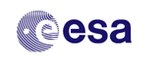
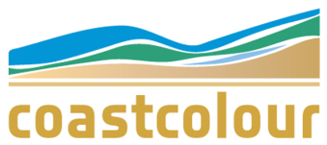
CoastColour User Registration Form
The CoastColour project is intended to improve user uptake of ESA's MERIS mission for applications in the coastal zones by developing, demonstrating and validating the latest advanced techniques for retrieving information on water constituents. In particular, the project aims to address the needs of:
- Scientists studying the bio- and geophysical processes in coastal waters, and
- Companies and government agencies who specialise in providing water quality information services

If you are interest in the project or if you are going to use CoastColour data in your application we would like to ask you to register as CoastColour user by filling out the form below. This registration is voluntary and access to the data is not bound to it. It will help us to improve our service.

Thank you very much!
Carsten Brockmann, CoastColour Coordinator

1. User Details
Contact name
Role or Position

Organisation

Email

2. Application

Please explain briefly what you are planning to do with the CoastColour data and in which geographic region you will work.

3. CoastColour User Community

I would like to receive further information about CoastColour, such as availability of new data, newsletter, announcement of User Consultation Meetings
□ YES □ NO
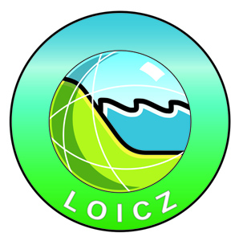
CoastColour is a
LOICZ affiliated project

